REKOD KEHADIRAN

A TTENDA NCE RECORD

TARIKH

(Date)

MASA MASUK

MASA KELUAR

TANDATANGA N

P ENY ELIA INDUS TRI

(Time In)

(Time Out)

(Industry *Supervisor’s* Signature)

08- 10- 2023

09- 10- 2023

10- 10- 2023

11- 10- 2023

12- 10- 2023

09:00 a.m.

09:00 a.m.

09:00 a.m.

09:00 a.m.

09:00 a.m.

18:00 p.m.

18:00 p.m.

18:00 p.m.

18:00 p.m.

18:00 p.m.

Friday

Saturday

15- 10- 2023

16- 10- 2023

17- 10- 2023

18- 10- 2023

19- 10- 2023

09:00 a.m.

09:00 a.m.

09:00 a.m.

09:00 a.m.

09:00 a.m.

18:00 p.m.

18:00 p.m.

18:00 p.m.

18:00 p.m.

18:00 p.m.

Friday

Saturday

22- 10- 2023

23- 10- 2023

24- 10- 2023

25- 10- 2023

26- 10- 2023

27- 10- 2023

09:00 a.m.

09:00 a.m.

09:00 a.m.

09:00 a.m.

09:00 a.m.

10:00 a.m.

18:00 p.m.

18:00 p.m.

18:00 p.m.

18:00 p.m.

22:00 p.m.

15:00 p.m.

Saturday

29- 10- 2023

30- 10- 2023

31- 10- 2023

01- 11- 2023

02- 11- 2023

09:00 a.m.

09:00 a.m.

09:00 a.m.

09:00 a.m.

09:00 a.m.

18:00 p.m.

18:00 p.m.

23:00 p.m.

18:00 p.m.

18:00 p.m.

Friday

Saturday

05- 11- 2023

06- 11- 2023

07- 11- 2023

08- 11- 2023

09- 11- 2023

09:00 a.m.

09:00 a.m.

09:00 a.m.

09:00 a.m.

09:00 a.m.

18:00 p.m.

18:00 p.m.

18:00 p.m.

18:00 p.m.

18:00 p.m.

Friday

Saturday

12- 11- 2023

13- 11- 2023

14- 11- 2023

09:00 a.m.

09:00 a.m.

09:00 a.m.

18:00 p.m.

18:00 p.m.

18:00 p.m.

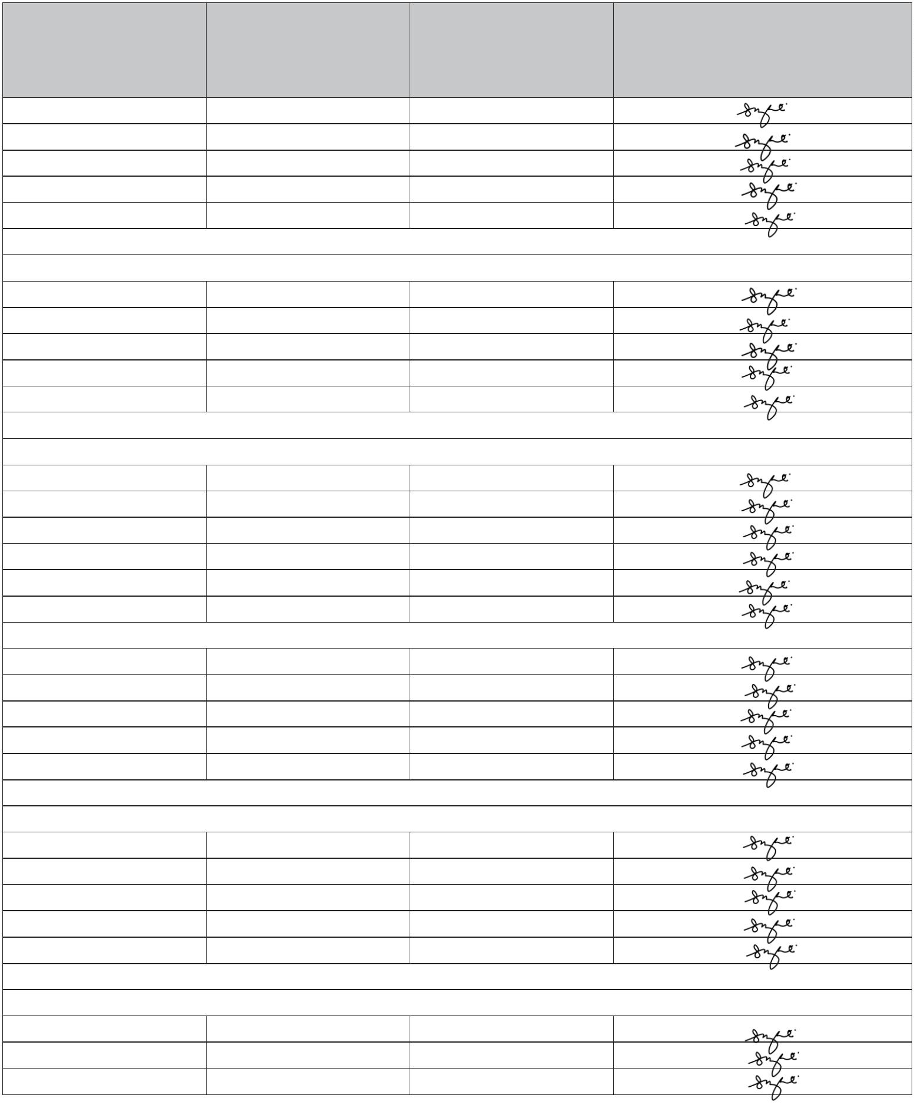

REKOD KEHADIRAN

Attendances Record

TARIKH

(Date)

MASA MASUK

MASA KELUAR

TANDATANGA N

P ENY ELIA INDUS TRI

(Time In)

(Time Out)

(Industry *Supervisor’s* Signature)

15- 11- 2023

16- 11- 2023

09:00 a.m.

09:00 a.m.

18:00 p.m.

18:00 p.m.

Friday

Saturday

19- 11- 2023

20- 11- 2023

21- 11- 2023

22- 11- 2023

23- 11- 2023

09:00 a.m.

09:00 a.m.

09:00 a.m.

09:00 a.m.

09:00 a.m.

18:00 p.m.

18:00 p.m.

18:00 p.m.

18:00 p.m.

18:00 p.m.

Friday

Saturday

26- 11- 2023

27- 11- 2023

28- 11- 2023

29- 11- 2023

30- 11- 2023

09:00 a.m.

09:00 a.m.

09:00 a.m.

09:00 a.m.

09:00 a.m.

18:00 p.m.

18:00 p.m.

18:00 p.m.

18:00 p.m.

18:00 p.m.

Friday

Saturday

03- 12- 2023

04- 12- 2023

05- 12- 2023

06- 12- 2023

07- 12- 2023

09:00 a.m.

09:00 a.m.

09:00 a.m.

09:00 a.m.

09:00 a.m.

18:00 p.m.

18:00 p.m.

18:00 p.m.

18:00 p.m.

18:00 p.m.

Friday

Saturday

10- 12- 2023

11- 12- 2023

12- 12- 2023

13- 12- 2023

14- 12- 2023

09:00 a.m.

09:00 a.m.

09:00 a.m.

09:00 a.m.

09:00 a.m.

22:00 p.m.

18:00 p.m.

18:00 p.m.

18:00 p.m.

18:00 p.m.

Friday

Saturday

17- 12- 2023

18- 12- 2023

19- 12- 2023

20- 12- 2023

21- 12- 2023

09:00 a.m.

09:00 a.m.

09:00 a.m.

09:00 a.m.

09:00 a.m.

18:00 p.m.

18:00 p.m.

13:00 p.m.

18:00 p.m.

18:00 p.m.

Friday

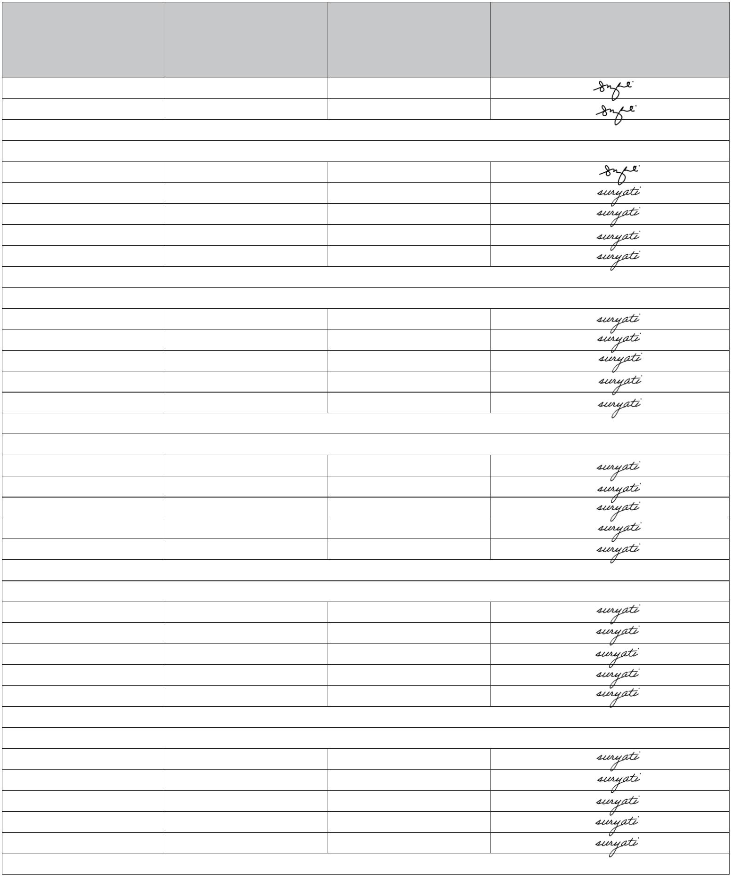

REKOD KEHADIRAN

Attendances Record

TARIKH

(Date)

MASA MASUK

MASA KELUAR

TANDATANGA N

P ENY ELIA INDUS TRI

(Time In)

(Time Out)

(Industry *Supervisor’s* Signature)

Saturday

Leave

Chrismast

18:00 p.m.

18:00 p.m.

18:00 p.m.

Friday

26- 12- 2023

27- 12- 2023

28- 12- 2023

09:00 a.m.

09:00 a.m.

09:00 a.m.

Saturday

18:00 p.m.

18:00 p.m.

18:00 p.m.

18:00 p.m.

18:00 p.m.

Friday

31- 12- 2023

01- 01- 2024

02- 01- 2024

03- 01- 2024

04- 01- 2024

09:00 a.m.

09:00 a.m.

09:00 a.m.

09:00 a.m.

09:00 a.m.

Saturday

18:00 p.m.

07- 01- 2024

09:00 a.m.

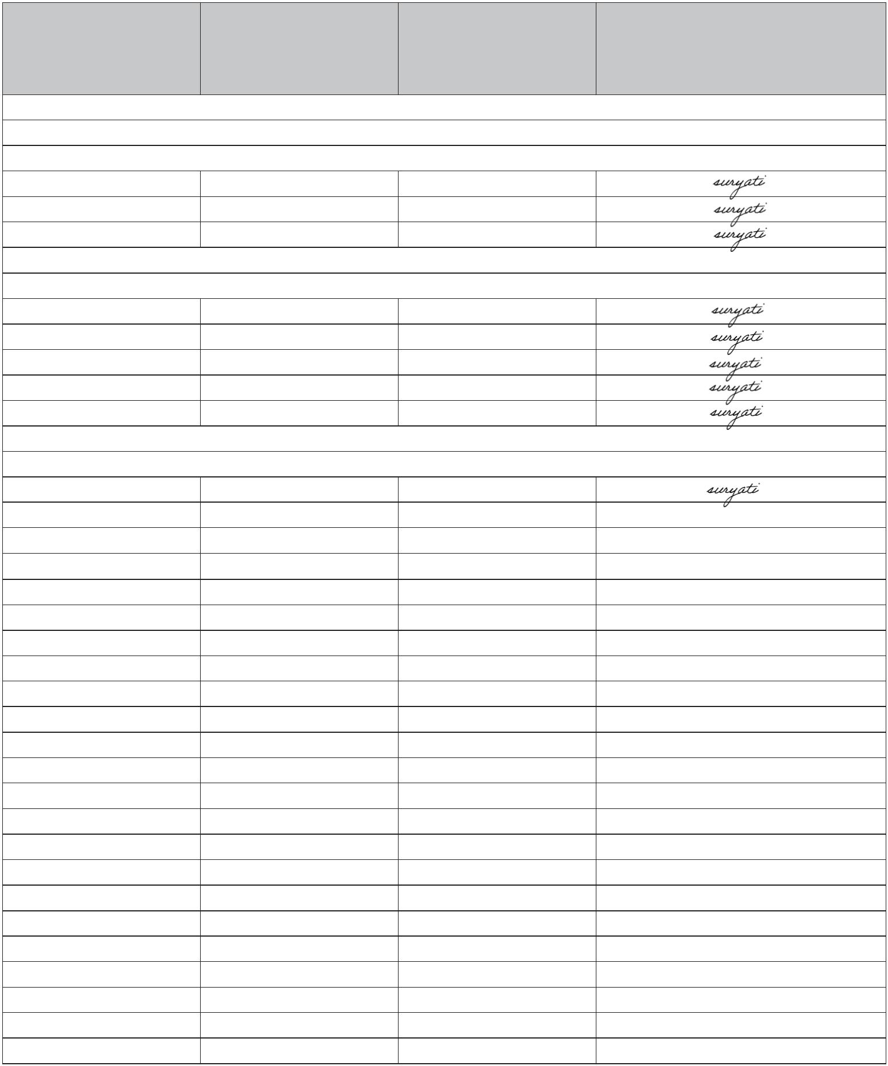

REKOD KEHADIRAN

Attendances Record

TARIKH

(Date)

MASA MASUK

MASA KELUAR

TANDATANGA N

P ENY ELIA INDUS TRI

(Time In)

(Time Out)

(Industry *Supervisor’s* Signature)

